Exercise 1: Mocking and Stubbing 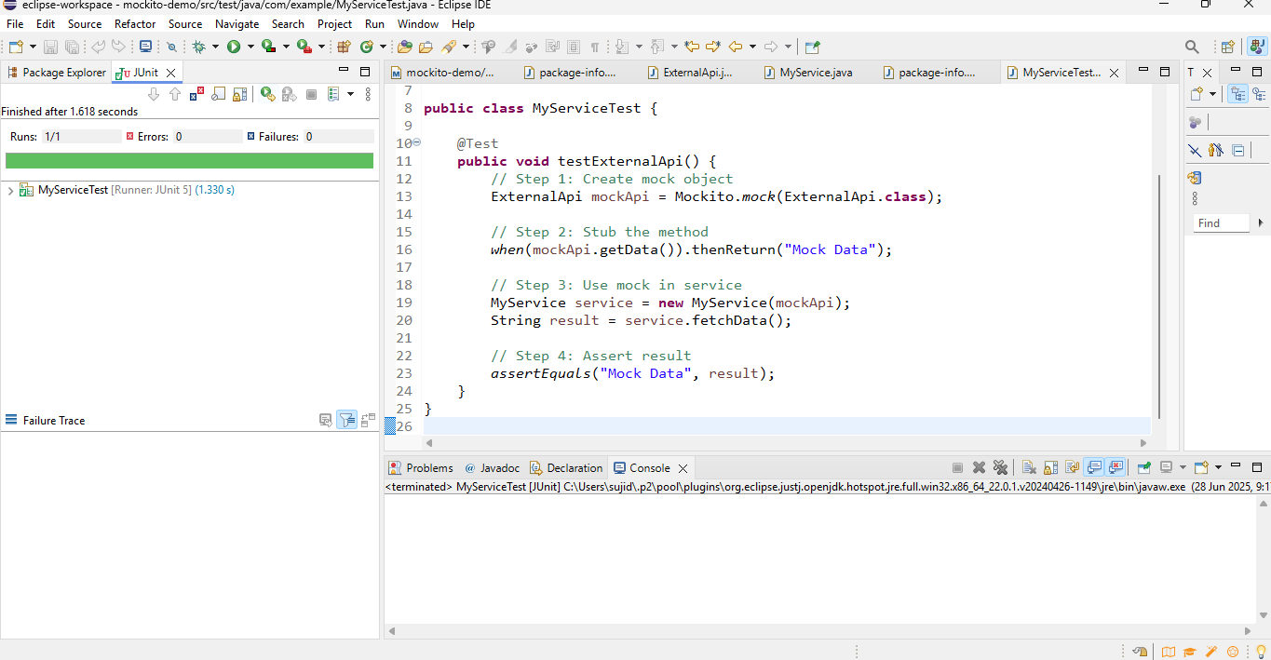

Exercise 2: Verifying Interactions

